**Fast and Slow Pointers**

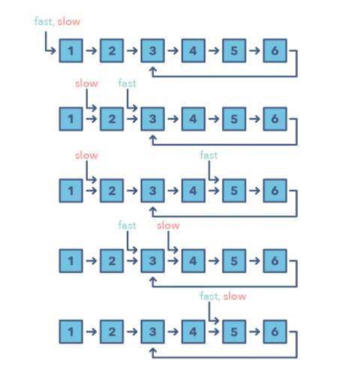

**Ways to Identify the pattern:**

* The problem will deal with a loop in a linked list or array
* When you need to know the position of a certain element or the overall length of the linked list.

**Common problems you use the sliding window pattern with:**

* Linked List Cycle (easy)
* Palindrome Linked List (medium)
* Cycle in a Circular Array (hard)

**Broad Categories:**

* Fast and Slow Pointers will meet at a particular point in the list

**Strategies to Solve the Problem:**

* Identify if you need to find a cycle in the list, middle of the list, position of certain element or the overall length of the linked list